Name: Alen Sebastian  
Reg_No: 20BCR7018

**SMARTBRIDGE EXTERNSHIP**

**Modern App Development Using Spring Boot**

**Week 2 Assignment**

* ***Create, update, delete commands in MySQL***

1. ***Create Command in SQL***

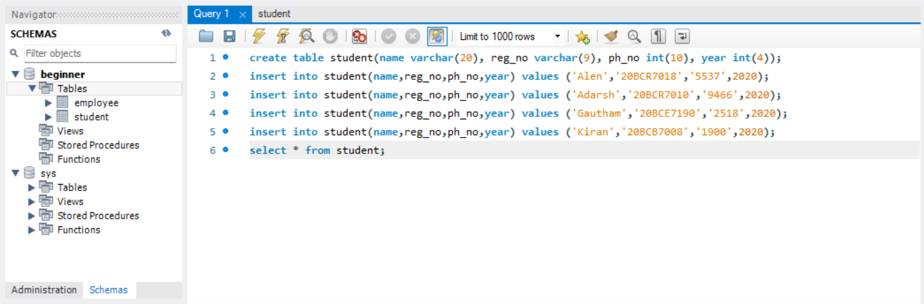

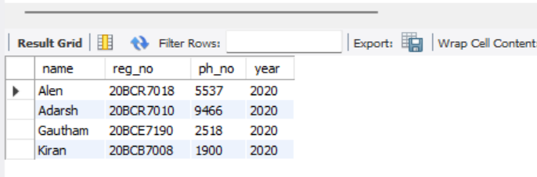

1. ***Update Command in SQL***



***Before:***



***After:***

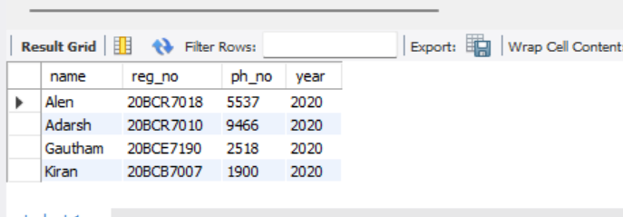

1. ***Delete command in SQL***

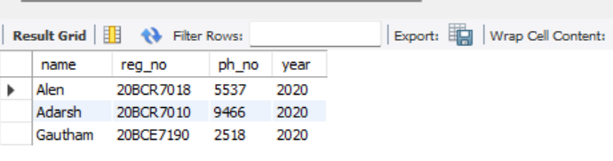

* ***Create tables and perform joins in sql***

***Employee Table:***

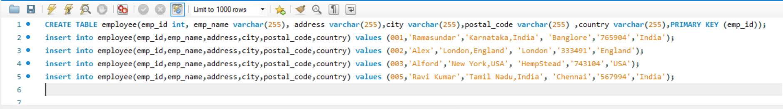

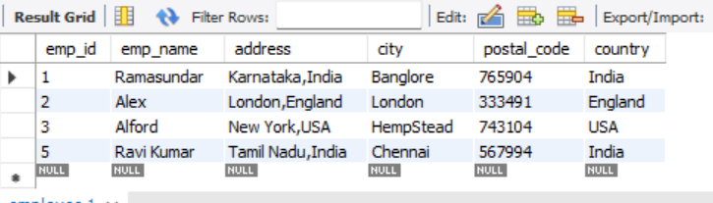

***Salary Table:***

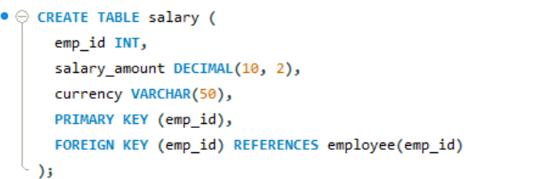

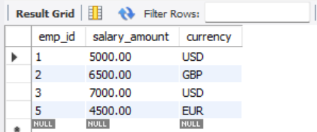

***Inner Join:***

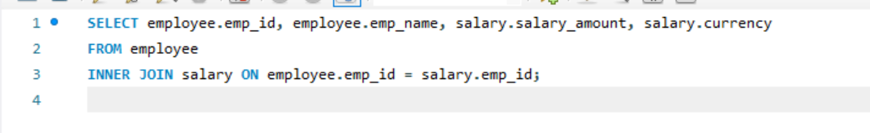

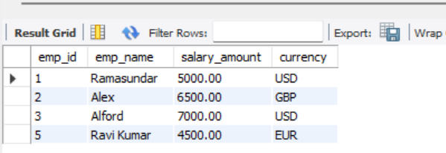

***Right Join:***

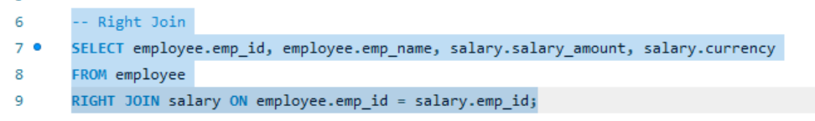

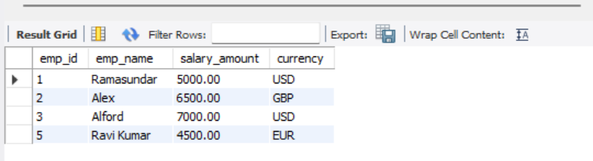

***Left Join:***

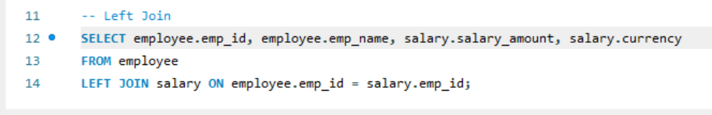

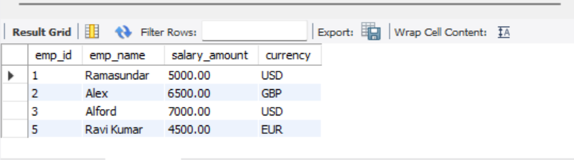

***Cross Join:***

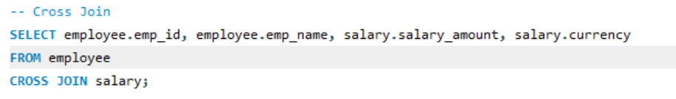

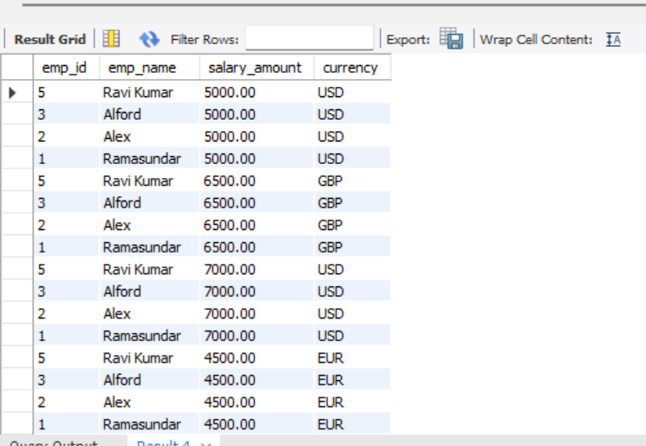

* ***Create, update, delete commands in MongoDB***

1. ***Create  
   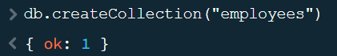***

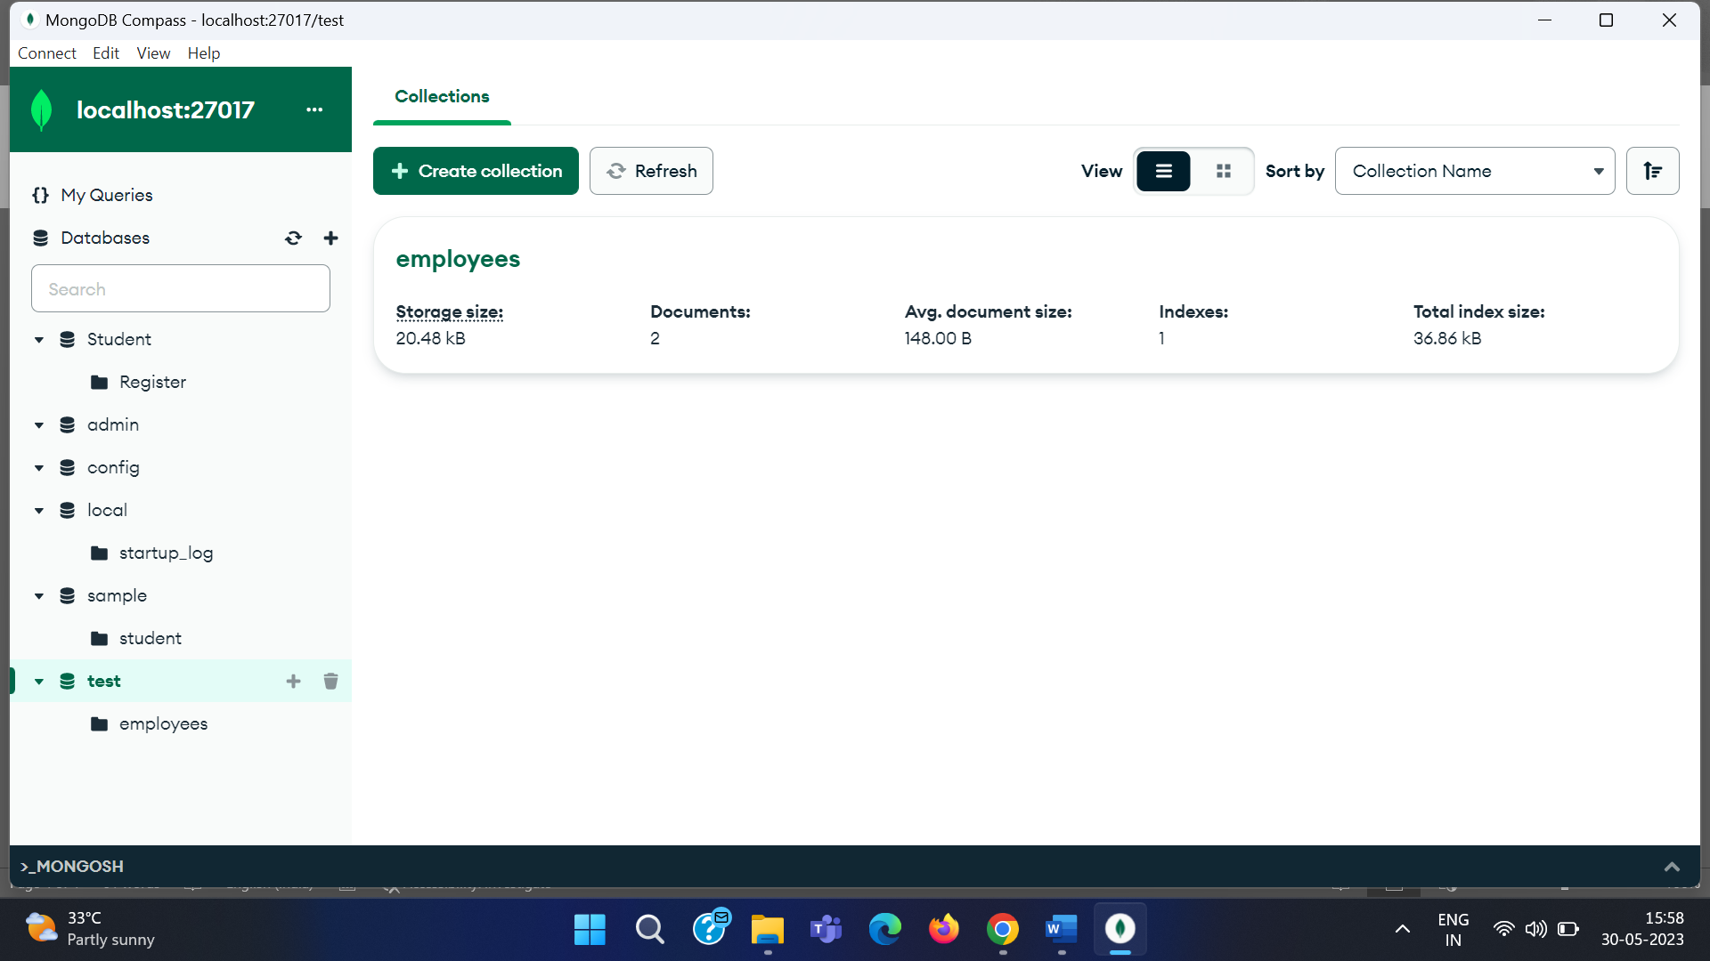

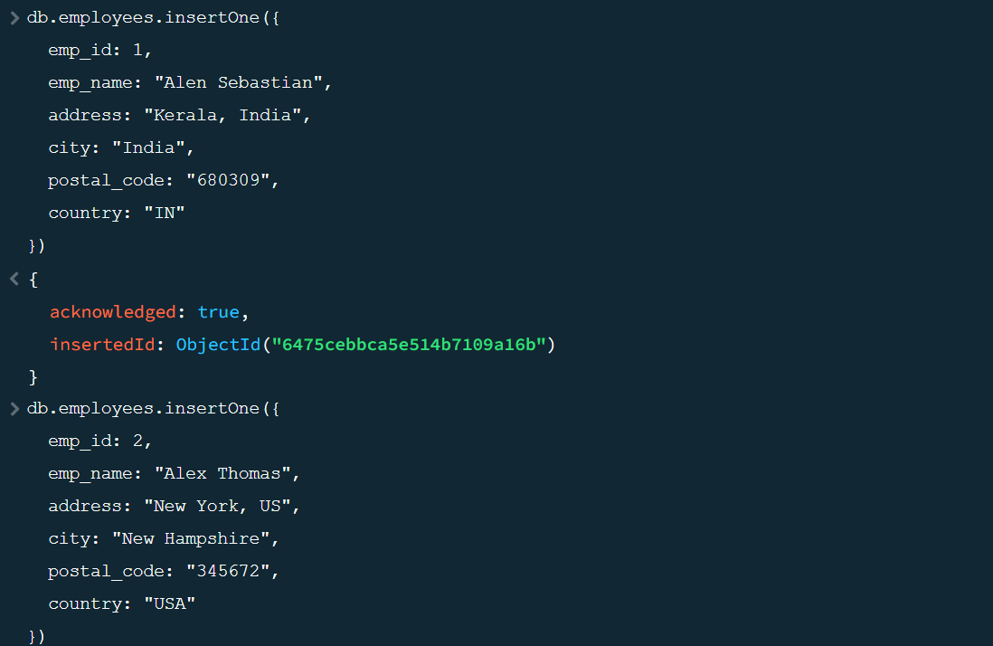

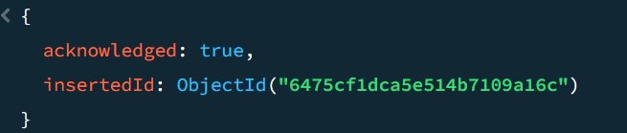

{

"_id": {

"$oid": "6475d13eca5e514b7109a16d"

},

"emp_id": 1,

"emp_name": "Alen Sebastian",

"address": "Kerala, India",

"city": "India",

"postal_code": "680309",

"country": "IN"

}

{

"_id": {

"$oid": "6475cf1dca5e514b7109a16c"

},

"emp_id": 2,

"emp_name": "Jane Smith",

"address": "New York, US",

"city": "San Francisco",

"postal_code": "345672",

"country": "USA"

}

1. ***Delete***

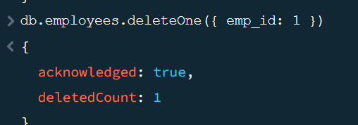

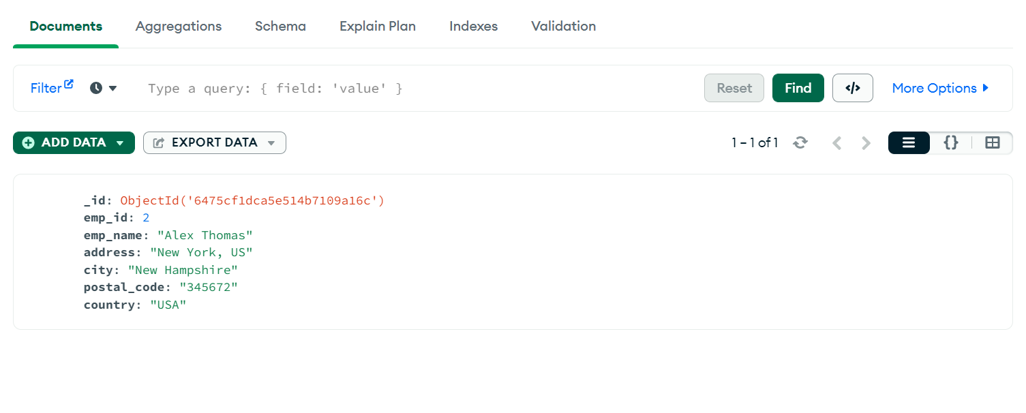

1. ***Update***

